Is an NIR Wearable In Reach

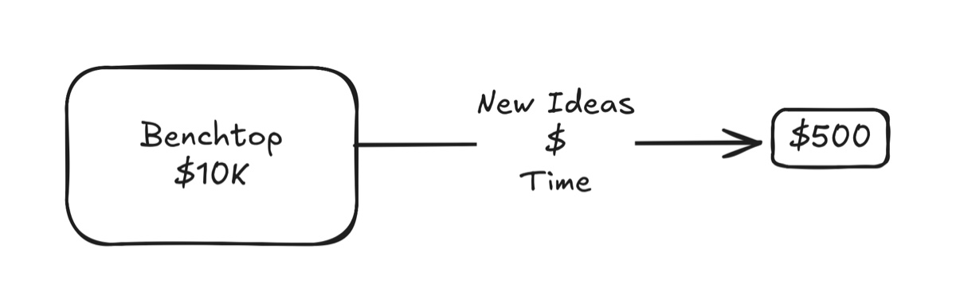

For the past couple of decades, no bench-top, near infrared system has achieved accuracy to meet ISO 15197:2013 or 21 CFR 862.1355. Let that soak in.

Mid-infrared systems scanning the “fingerprint region” can do a good job of identifying glucose in human plasma but the penetration depth of mid-infrared is unsuitable. The Rockley Photonics wearable spectrometer was/is an exciting example of a wearable mid-IR spectrometer targeting glucose. No joy.

Despite the best efforts by physicists, electrical engineers, chemometricians, mathematicians, and chemists, performance to dose insulin has been elusive using high performance lasers and benchtop spectrometers.

Commissioned by Steve Jobs, enjoying enviable research budgets, Apple Computer has not presented a wrist-wearable that is an alternative to a fingerstick costing pennies per test, or an over-the-counter iCGM at about $3 per day.

Why?

Near-infrared (near IR) Raman spectroscopy and enzyme‐based electrochemical methods (using glucose oxidase) approach glucose detection very differently. Here’s why near IR Raman spectroscopy lacks the inherent specificity of glucose oxidase:

Nature of the Signal:

• Raman Spectroscopy: This technique measures vibrational energy levels of molecules via inelastic scattering of light. In complex biological samples, many molecules—including proteins, lipids, and other sugars—exhibit overlapping vibrational bands. Glucose’s spectral features in the near IR region are often weak and not uniquely distinct, making it hard to isolate its signal from background interference.

• Glucose Oxidase: The enzyme is highly selective. It binds specifically to glucose and catalyzes its oxidation, producing a reaction product (such as hydrogen peroxide) that is directly and quantitatively measured electrochemically. This reaction mechanism inherently filters out other molecules.

Selectivity and Specificity:

• Raman Approach: Because Raman spectra result from the sum of vibrational modes from all present species, even subtle similarities between glucose and other compounds can lead to overlapping features. This overlap reduces the technique’s chemical specificity without extensive post-processing and calibration.

• Enzymatic Reaction: Glucose oxidase has an active site that is evolutionarily optimized to interact only with glucose. This molecular “lock and key” mechanism provides a level of specificity that is difficult to achieve with a broad-spectrum physical technique like Raman spectroscopy.

Signal Intensity and Interferences:

• Raman Limitations: Raman scattering is an inherently weak process, especially in the near IR range, and the signal for glucose can be easily overwhelmed by stronger signals from water or other abundant biomolecules. Even if glucose has a characteristic Raman signature, its weak signal combined with interference makes accurate quantification challenging.

• Enzymatic Amplification: The glucose oxidase reaction converts a single glucose molecule into a measurable product, effectively amplifying the signal. This biochemical amplification bypasses many of the optical interferences that affect Raman measurements.

Environmental and Calibration Challenges:

• Raman Spectroscopy: Variations in sample composition, temperature, and instrument conditions can further complicate the spectral analysis. Complex multivariate calibration methods are often required to extract meaningful data for glucose, and even then, the risk of cross-sensitivity remains.

• Electrochemical Sensors: The enzymatic reaction provides a direct, reproducible pathway to glucose detection. Once the sensor is calibrated, the measurement is less prone to interference from other species, ensuring reliable and specific quantification.

In summary, while near IR Raman spectroscopy can provide a molecular fingerprint, its reliance on detecting subtle and often overlapping vibrational signals makes it less specific for glucose detection. In contrast, glucose oxidase’s natural substrate specificity and the clear, amplified electrochemical signal from its reaction make it a much more precise tool for quantifying glucose.

Where To Go From Here?

Re-purpose the effort to achieve a wearable alternative to fingersticks or continuous glucose monitors to bring a new metabolic monitor.

Leverage the current enthusiasm for wellness wearables. e.g., smart rings, application of AI including machine learning and cloud-based large language models. Bring a *metabolic activity* signal into a model accessing wearable sensors.

Iterate an *Indications For Use* statement to fit problem and solution in a wearable form.

Start with a wearable form-factor that approximates a thickened smart watch. Identify commercially-available near infrared energy sources to combine in the wearable.

Proposed Block Diagram

